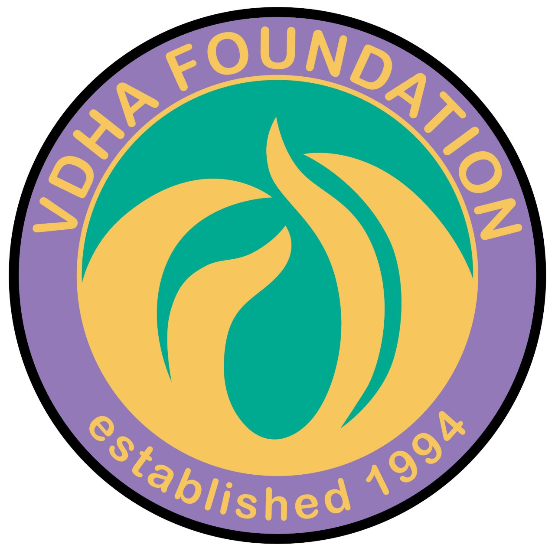

VIRGINIA DENTAL HYGIENISTS’ ASSOCIATION FOUNDATION HONOR ROLL REPORT OF GIFTS
January 1, 2018 through December 31, 2018

JEFFERSON CLUB
Northern Virginia Hygienists’ Association
In memory of Patricia A. Golliday, RDH

PATRIOT CLUB
Cathy Berard
James H. Forsberg
In honor of the birthday of my daughter, Julie Simms
Marge Green
In honor of Sheila Sheats & Karen Avey
In honor of ADHA District III Trustee,
Dawn A. Dean, RDH, MSDH
Meg Lemaster
In memory of Michelle Darby
Nancy Martin
In honor of Brian Martin
Elaine Newland
In memory of Paul B. Summey II
Susan Pharr, BSDH, MPH
In honor of my VDHA colleagues
Sheila Sheats
Julie Simms
In honor of my dad, Jim Forsberg and in memory of Cynthia Forsberg, Ted and Vicki Simms
Greater Richmond Dental Hygienists’ Component
Monticello Dental Hygienists’ Component
Tidewater Dental Hygienists’ Component
PATRIOT CLUB (continued)
Peninsula Dental Hygienists’ Component
In honor of Julie Martin, Chair

DONOR CLUB
Julie Allen
Karen Avey
Melanie Bartlam
Dr. Patricia Bonwell
Stacia Brooks
Maria Camacho-Bell
Betsy Di Silvio
In memory of Judy Walsh
Linda Gill
Evelyn D. Grant, RDH, MBA
Catherine Johnson
Judith Knight
Joyce Kwiatkowski-Spieler
In honor of Volunteerism
Patricia MacDougall
Sheryl Manion
Julie Martin
Margaret Martin
In memory of Robert F. Jackson, DDS
Maureen McCann
In memory of my father, Martin, who always encouraged us to reach for the stars!
Carolyn Moore
John & Sheri Moore
In honor of Jamie Davila
DONOR CLUB (continued)
Elizabeth Peebles
Jackie Perry
Susan Pharr
In honor of my VDHA colleagues
Susan Reid-Carr, BS, RDH
Rhea Rossi
Janis Slezak
Kathy Cunningham Starr
In memory of Patricia Golliday, RDH
Moe Thompson
In honor of Woodrow Grayson Schmidt
Christina Tulloch
Southwest Dental Hygienists’ Component

All contributions enable VDHA Foundation to continue to make a significant difference in the lives of many. Thank you to all who have contributed this past year to continue the work of the Virginia Dental Hygienists’ Association Foundation. Your tax-exempt donation will be utilized in performing the charitable, educational, research and scientific activities of the association. If you would like to make a donation, please send it to: Marge Green, VDHA Foundation Treasurer, 1919 Old York Hampton Highway, Yorktown, VA 23692-4143

