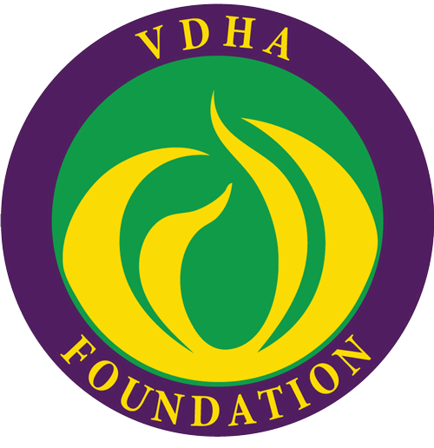

VIRGINIA DENTAL HYGIENISTS’ ASSOCIATION FOUNDATION
HONOR ROLL REPORT OF GIFTS
May 1, 2015 through November 11, 2016

JEFFERSON CLUB
Northern Virginia Hygienists’ Association
In memory of Patricia A. Golliday, RDH

PATRIOT CLUB
James Forsberg
In celebration of my daughter, Julie Simms' birthday, October 13th
Mary Morrison Littleton
In honor of Agnes Morrison
Nancy Martin
In honor of Brian Martin
Sheila Sheats
In memory of my mother Ernestine P. Brown
In memory of Pat Wheeler mother of Melanie Bartlam
Julie Simms
In honor of my dad, Jim Forsberg and in memory of my mom, Cynthia Forsberg
Moe Thompson
In honor of the Southwest Virginia DHA
In honor of the recent weddings of my children

Monticello Dental Hygienists’ Association
Tidewater Virginia Dental Hygienists’ Association

DONOR CLUB
Julie Y. Allen
Karen Avey
Melanie Bartlam
In memory of Ernestine P. Brown, mother of Sheila Sheats

Cathy Berard
In memory of Pat Wheeler mother of Melanie Bartlam
In memory of Ernestine P. Brown, mother of Sheila Sheats
Stacia Brooks
Irene Connolly, RDH, BS, MS
In honor of Jackie Perry, RDH, BS, MS
Betsy Di Silvio
In memory of Judith A. Walsh
Linda Gill
In memory of Mr. Tom Smith
Evelyn D. Grant
In honor of Monticello DHA
Marge Green
In appreciation of Barry Lee Green
In honor of PDHA Immediate Past President, Jessica Suedbeck
Catherine Johnson
Judith Knight
Michelle McGregor
Patricia MacDougall
Mimi Magyar
In honor of Monticello DHA
Julie Martin
Margaret Martin
In memory of Robert F. Jackson, DDS
Tracy Martin, RDH, BSDH
Maureen McCann
In appreciation for all ADHA members
Sheri Moore
Elaine Newland
In memory of Ernestine P. Brown, mother of Sheila Sheats
Joan Perez
Bonnie Perry
In appreciation for my VDHA family
Jackie Perry
Susan H. Pharr, BSDH, MPH
Rita Phillips, RDH, PhD
Susan Reid-Carr
In memory of Pat Wheeler mother of Melanie Bartlam
In memory of Jesse W. Reid, Jr.

Patricia Shand, BSc, RDH
In honor of Daniel Gallagher
Kathleen Sloan
In honor of Lynn Boland
Maloy Van Faussien
In honor of Gloria Livingston's RDH retirement

Greater Richmond Dental Hygienists’ Association
North West Dental Hygienists’ Association
Peninsula Dental Hygienists’ Association
Southwest Virginia Dental Hygienists’ Association

All contributions enable VDHA Foundation to continue to make a significant difference in the lives of many. Thank you to all who have contributed this past year to continue the work of the Virginia Dental Hygienists’ Association Foundation. Your tax-exempt donation will be utilized in performing the charitable, educational, research and scientific activities of the association. If you would like to make a donation, please send it to: Marge Green, VDHA Foundation Treasurer, 1919 Old York Hampton Highway, Yorktown, VA 23692-4143

