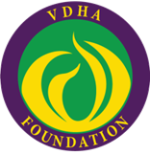

Virginia Dental Hygienists’ Association Foundation
Program Proposal Evaluation Criteria
Reviewers will perform a peer review of all proposals using the rubric below, with the opportunity to provide comments to the submitting presenter.

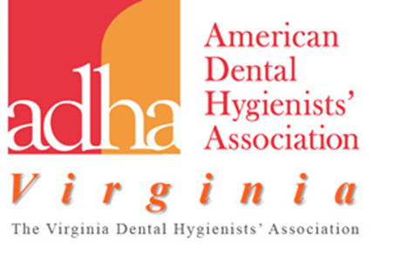

Criterion |  |  |  | Excellent  3 |  | Good  2 |  | Feedback for Improvement  1  1
Content |  |  |  | The proposal addresses issues relevant to the professional roles of the dental hygienist with evidence that is based on current best practices and the ADHA Standards of Clinical Dental Hygiene Practice. |  | The proposal focuses on issues and evidence that are based on current best practices and the ADHA Standards of Clinical Dental Hygiene Practice. |  | The focus needs to more clearly indicate its importance and relevance to the professional roles of the dental hygienist.
Clarity |  |  |  | Title, description and educational objectives of the program are clearly identified. |  | Title, description and educational objectives of the program are generally well described. |  | Title, description and / or the educational objectives are incomplete and unclear.
Format  (Select one) |  | Educational Programs  or |  | The proposal clearly addresses the professional development goals of the VDHA and is founded in well-reasoned thinking and / or evidence based science. |  | The proposal addresses the professional development goals of the VDHA and is founded in well-reasoned thinking and / or evidence based science. |  | Connection to the professional development goals of the VDHA needs to be demonstrated as well as evidenced based science.
 |  |  | Workshop/ Small Group Discussion |  | The proposal demonstrates a high level of interactivity among participants in an active learning environment. |  | The proposal shows evidence of interaction among participants. |  | The proposal needs modification or editorial revision to demonstrate evidence of interaction among participants.
Professional  Writing |  |  |  | The proposal is clearly written. |  | The proposal requires some minor adjustments. |  | The proposal requires revision to achieve understanding of its purpose and intent.  Intent.
Contribution |  |  |  | The proposal will make a significant contribution and should attract a large number of participants from areas within the dental hygiene profession or the audience specified by the VDHA. |  | The proposal should make a meaningful contribution and should be of interest to at least some of the participants within the dental hygiene profession or the audience specified by the VDHA. |  | Connection to the professional development goals of the VDHA as well as evidence based science needs to be demonstrated.
CONFLICT OF INTEREST
The proposal discloses any monetary or special interest the presenter may have with a company whose products are discussed in the continuing education program.
The proposal discloses external funding for the course to the reviewers and subsequently to the participants in promotional and educational materials.
***To present at a VDHA sponsored event, a dental hygienist must provide evidence of ADHA membership.

