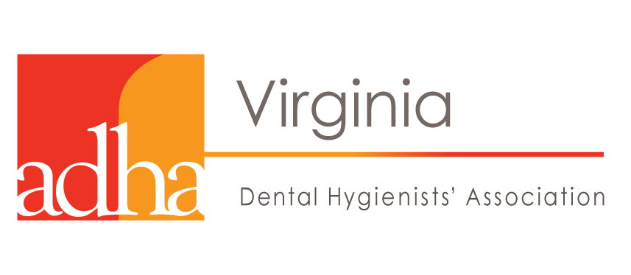
HB1474 (Orrock) Dental Hygiene; Remote Supervision

- The Virginia Dental Hygienists’ Association (VDHA) and the Virginia Dental Association (VDA) worked together last session to pass legislation to expand remote supervision of Registered Dental Hygienists to new settings, such as health clinics, schools, nursing homes, etc. to help serve more patients.
- Since implementation of the new law, we have discovered a few minor issues that need to be fixed. These changes will ensure that more Virginians are able to access to oral health care.
- HB 1474, supported by both VDHA and VDA makes the following updates, supported:
  - Dental hygienists will no longer have to be employed by the supervising dentist. It’s been changed to allow the clinics and facilities to employ the hygienist.
  - As long as a patient verbally confirms they do not have a dentist, the dental hygienist does not need permission from the dentist.
  - Dental hygienists no longer have to contact the dentist prior to serving someone with medical complexities, as long as a written protocol is established beforehand.

Current Law: 54.1-2722 F. For the purposes of this subsection, "remote supervision" means that a dentist is accessible and available for communication and consultation with a dental hygienist employed by such dentist during the delivery of dental hygiene services but such dentist may not have conducted an initial examination of the patients who are to be seen and treated by the dental hygienist and may not be present with the dental hygienist when dental hygiene services are being provided.
Virginia Dental Hygienists’ Association
www.vdha.net
HB1474 (Orrock) Dental Hygiene; Remote Supervision

- The Virginia Dental Hygienists’ Association (VDHA) and the Virginia Dental Association (VDA) worked together last session to pass legislation to expand remote supervision of Registered Dental Hygienists to new settings, such as health clinics, schools, nursing homes, etc. to help serve more patients.
- Since implementation of the new law, we have discovered a few minor issues that need to be fixed. These changes will ensure that more Virginians are able to access to oral health care.
- HB 1474, supported by both VDHA and VDA makes the following updates, supported:
  - Dental hygienists will no longer have to be employed by the supervising dentist. It’s been changed to allow the clinics and facilities to employ the hygienist.
  - As long as a patient verbally confirms they do not have a dentist, the dental hygienist does not need permission from the dentist.
  - Dental hygienists no longer have to contact the dentist prior to serving someone with medical complexities, as long as a written protocol is established beforehand.

Current Law: 54.1-2722 F. For the purposes of this subsection, "remote supervision" means that a dentist is accessible and available for communication and consultation with a dental hygienist employed by such dentist during the delivery of dental hygiene services but such dentist may not have conducted an initial examination of the patients who are to be seen and treated by the dental hygienist and may not be present with the dental hygienist when dental hygiene services are being provided.
Virginia Dental Hygienists’ Association
www.vdha.net

